**********************HANDLERS***************************************************
- Notify handlers are always run in the same order they are defined, not in the order listed in the notify-statement. This is also the case for handlers using listen.
- Handler names and listen topics live in a global namespace.
- If two handler tasks have the same name, only one will run.
- If we don’t mention notify playbook will run no errors but handlers will not run.
****************Use Playbook in crontab***************************************************
# whereis ansible-playbook
/usr/bin/ansible-playbook
and run with the path displayed in the output
we can run with this in crontab
#crontab -e

*/15 * * * * /usr/bin/ansible-playbook /home/user1/yourplaybook.yml
It worked like charm

**********************Rolling Updates Info**********************************************
https://docs.ansible.com/ansible/latest/user_guide/playbooks_delegation.html#interrupt-execution-on-any-error
******************************************************************************************

**************Delegate_to & Registar & Debug Modules*************************************
https://www.youtube.com/watch?v=pIt9Z2PJvnc
Debug: is used as Print command. if no “msg:” is specified then it shows hello World
Registar: Stores the output, or used as storing the command out put like yes or no in if-else statement etc.
Delegate_to: Used for Specfic hosts or group of hosts even though the playbook is intended for some other hosts. Used mostly to remove servers from load balancers. Used with “serial Module”

example:

- Name: printout
Command: hostnamectl
Delegate_to: localhost
Register: host
- Debug:
Msg: {{host.stdout}}
Msg: “{{ host }}”
***************************************************************************

Deployment example/ Rolling Updates With Zero Downtime Example:

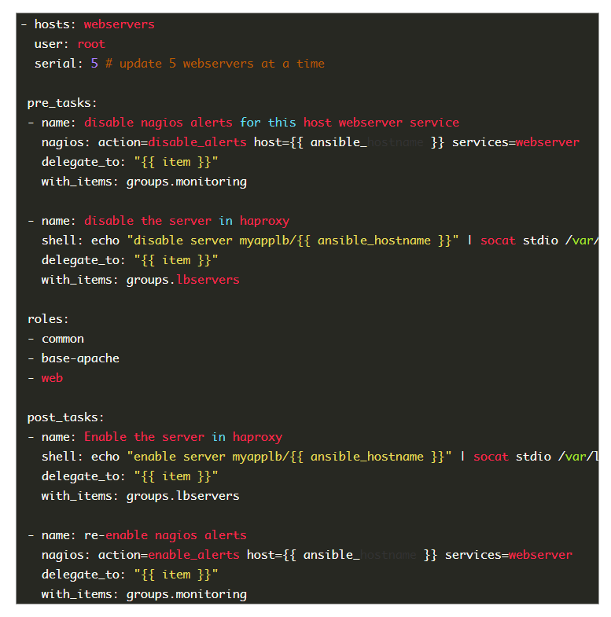

Also mention after first 3 lines:

Max_fail_percentage: 30 # so if 30% of the servers fail then exit the playbook
Any_errors_fatal: true # if any fatal error it will quit. With the ‘’any_errors_fatal’’ option, any failure on any host in a multi-host play will be treated as fatal and Ansible will exit immediately without waiting for the other hosts.
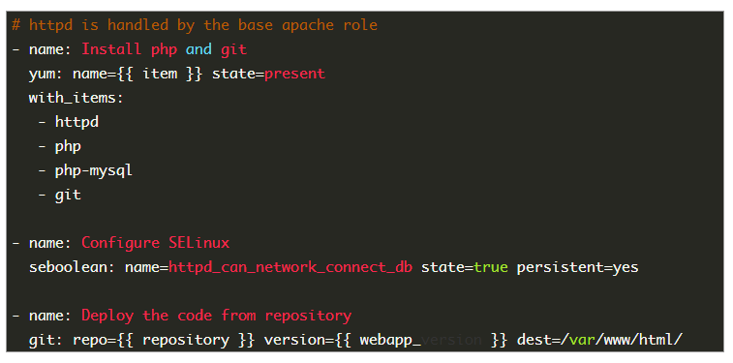

*************Tags*************************************

Tags: mentioned just below a task. If u want to run specific task then use –tags or skip-tags option while running the playbook and also mention the tagname within “” in the command line
- Tags can be mentioned for multiple task. Special tags with “always mentioned” will run every time until specifically skipped.

Task:
- Name: install a package
Yum: name=git state=latest
Tag:
-packages
-always # special tag name
****************************************Run Once*************************************
The 'run_once' parameter is designed to run a specific play in a playbook once PER PLAYBOOK, even if there are multiple hosts referenced in the playbook (i.e. you are running a playbook that starts with a database migration and that playbook runs against multiple databases in a cluster, the migration only needs to happen on one host, but that play can then be skipped on the remaining hosts since it is done).

In your case, the behavior you are seeing is intended in that it is running once on a host EACH TIME you are executing the playbook. The run_once parameter does not restrict that item from running again on subsequent executions of the playbook, only from running more than once within that playbook.

After a task:
Run_once: true

This directive forces the task to attempt execution on the first host in the current batch
**************************Async and Polling*********************************************
Is where u r concerned about a task that may exceed ssh timeout. In this case u mention async > time it will take to complete the process if the async time is less than the command time out then after the async sec it will throw error and exit hence always mention more time than command time.
Poll > check for every mentioned sec. that the task had been completed or not? Default:10 sec
Command: sleep 60
Async: 70
Poll: 25

Also if we want a task to initiate and don’t care if it ran successfully or not make poll=0 sec.
https://www.youtube.com/watch?v=iRNM0--84vI
*************************************************************************************

**********Conditional when and Stat module***********************************************

task:
- name: install httpd if yum
Yum: name=httpd state=latest
When: Ansible_distribution == “CentOS”
- name: install httpd(apache) when its Debian
Yum: pkg= apache2 state=latest
When: ansible_distribution == “Debian”

-stat:
Path: /etc/folder/file
Register: output
Task:
Command: touch file.txt
When: Output.stat.exists == false
OR

tasks:
- name: Check that the somefile.conf exists
stat:
path: /etc/file.txt
register: stat_result

- name: Create the file, if it doesnt exist already
file:
path: /etc/file.txt
state: touch
when: stat_result.stat.exists == False

Stat: is used to check if dir or file is present or not. For dir >> p.stat.isdir

When is for conditional statement.

---------------------------Vars_promt and install user defined packages -------------------------

---
- hosts: all
become: true
become_user: root
gather_facts: true
vars_prompt:
- name: "ve"
prompt: "Which version Do you want to install?"
private: no
default: httpd
tasks:
- name: Ansible prompt example
yum: name="{{ve}}" state=latest update_cache=true

**********************************************************************************************
-------------------Ansible loops---------------------------------------------------------------
---
- hosts: all
become: true
become_user: root
tasks:
- name: install packages with loop
yum: name="{{ item }}" state=latest update_cache=true
with_items:
- httpd
- htop
- httpd-tools
- logwatch
- ftp

// normal loop

---
- hosts: localhost
gather_facts: no
tasks:
- name: Loop over lines in a file
debug:
var: item
with_lines: cat "./files/lines"

